# BBT’s draft Bow-ties: Guidance for next steps towards finalisation

In this document we summarise the guidance for the BBTs to revise their draft Bow-ties (BTs) towards their final version. The clarifications and suggestions provided originate form the examination of the draft BTs delivered by the BBTs (up to March 2024) and have the aim of harmonising the BTs across BBTs by standardising their structure and content, also in preparation of the downscaling of high-level scenarios.

The figure below gives an example of how the resulting BT diagram would look like after the suggestions below (indicated in red in the figure) have been implemented. Please note that the main aim of this figure is to show the structure and organisation of the content of a finalised BT, while the formatting (text size, colouring etc) is only indicative and can be adjusted (e.g. BBTs might choose to colour the consequences differently according to type (for the economy, society etc)). The diagram below was created in Power point, but the BBTs have the freedom of using whichever platform they prefer, as long as the structure and content are standardised.

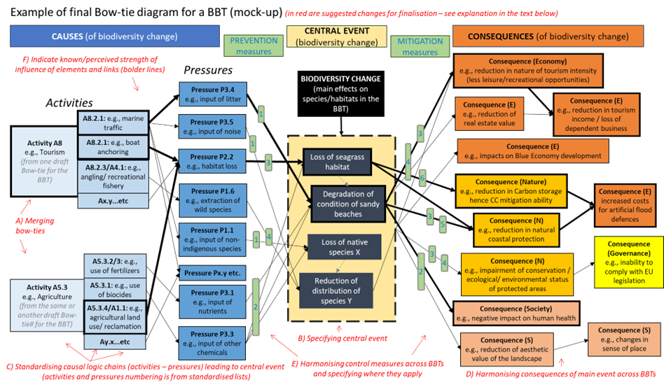

## A) MERGING BOW-TIES:

Now that the BBTs have produced draft BTs for individual problems, we suggest that these are merged into one (i.e., **one final BT per BBT**). In fact, the different problems in a BBT do not exist in isolation and they might interact, e.g., generating similar pressures and affecting similar elements of the BBT biodiversity (cumulative effects), or having similar consequences and control measures.

## B) CENTRAL EVENT:

The central element of the BT represents the ‘undesirable event’ or ‘event to be avoided’, which in the case of MARBEFES is an unwanted change in biodiversity. This element is currently generically expressed as ’species/habitats affected’.

The next step for the BBTs is **to specify the central event for the specific bow-tie**, i.e. by specifying which change in biodiversity is of main importance/concern in the BBT in terms of which habitat, species or processes of biodiversity are most affected by the selected pressures in the BBT and how (what changes).

Note that this may mean to split the central event into a group of central events (if different changes for different species, habitats or processes are relevant for the BBT). This may help in identifying more specific consequences and control measures.

There are no standardised lists of the possible central events, as these may be variate and are specific to the BBT and the BT of interest. Some examples are: reduction in seagrass cover, reduction in herring population, loss of mud for carbon sequestration; if possible, specify an amount of change, e.g. 50% reduction in northern shrimp population.

Note that some biodiversity changes (at the centre) may be affected by different causes compared to others also due to their different spatial occurrence (this might be especially relevant when merging different bow-ties). E.g., activities/pressures that mainly occur in the coastal area of the BBT would affect element of biodiversity distributed in this area (e.g., anchoring of tourist ships may lead to physical disturbance and loss of seagrass) but unlikely to affect other biodiversity components offshore, which, in turn, may be affected by offshore activities and associated pressures (e.g., physical impact offshore wind farm turbine might lead to distribution change of migratory birds (due to collision impacts, avoidance and changes in migratory routes)).

Also, the changes in biodiversity that are specified as central event(s) are likely to represent broad scale changes (at the higher levels of ecological organisation, e.g., population or habitat) that may result from smaller scale changes (e.g., physiological effects due or leading to reduced tolerance or survival, increased mortality, impaired reproduction). These latter changes are effectively part of the biodiversity change at the centre of the bow-tie, although they might be only implicitly included in the BT diagram (however, if specified, they should be part of the central event).

## C) CAUSES:

The direct causes for changes in biodiversity are the pressures exerted on the environment by human activities. Therefore, direct links exist between pressures (on the left) and the changes in biodiversity at the centre of the BT. However, it may be easier to also explicit the activities generating the pressures via logic chains on the left of the BT (i.e., links between activities and pressures, leading to links between pressures and central event). Activities may be expressed at different levels (e.g., at higher level, for example as sector, and as a more specific activity – e.g., anchoring is one of the specific activities within tourism that may lead to particular pressures). **Making the logic chains explicit may help** in identifying the main pressures affecting biodiversity.

Many BTs already include both activities and pressures. We recommend that the BBTs **double check their BTs to make sure that the main relevant logic chains for the problem of interest are included** (or the relevant pressures at least) and that any link between an activity and a change in biodiversity is always mediated (pass through) a pressure, so that only pressures are directly linked to the central events.

We have provided **standardised lists of causes** (activities and pressures) that the BBTs may use to standardise their BTs (also for the downscaling of high-scale scenarios). These lists are based on standard lists from MSFD, further improved by specifying activities or pressure to a higher detail as relevant to the BBTs’ bow-ties and harmonising terms with those used in high-scale scenarios.

Please note that the causes of interest in the MARBEFES bow-ties are those directly leading to changes in biodiversity at the centre of the BT. It is acknowledged that some activities may have other effects (directly affecting the local economy, society etc) but these may not be mediated by changes in biodiversity and therefore are not relevant to the MARBEFES bow ties. For this reason, there cannot be direct links between causes on the left of the BT and consequences on the right of the BT, i.e., links that don’t pass through a change in biodiversity in the middle. For the same reason, there cannot be causes on the left of the BT that are not connected (directly if pressures or indirectly via pressures if activities) to changes in biodiversity at the centre of the BT. **We encourage BBTs to double check their BTs for this**.

Also note that pressures may directly affect the environment via physico-chemical changes (e.g., temperature increase, turbidity increase). These are formally state changes, but as the central element of the MARBEFES BT focuses on effects on biodiversity (hence ecological state changes), the physico-chemical state change would mediate the effects of pressures on the ecology and therefore they should be included in the logic chains on the left of the BT.

## D) CONSEQUENCES:

The elements on the right of the BT represent the consequences of the changes in biodiversity in the BBT, i.e., the impacts that the biodiversity changes at the centre of the BT have on other parts of the ecosystem or on human welfare (economy, society, nature, governance etc). Any consequence on the right of the BT is therefore a consequence of the change in biodiversity induced by the activities and pressures on the left, rather than a direct consequence of the activities (not mediated by biodiversity changes at the centre). **We encourage BBTs to double check their BTs for this.**

It should be noted that also on the right-hand side of the BT there may be logic chains linking a central event (aspect of change in biodiversity in the BBT) to primary (direct) consequences, and the latter to secondary consequences (and tertiary if needed) within the same category (e.g., the change in biodiversity might lead to economic losses via a reduction of the tourism intensity) or between categories (e.g., the biodiversity change in the BBT might lead to a decrease in the environmental status in the region (consequence for nature), thus leading to the inability of the Member State to comply with EU MSFD requirements (consequence for governance) and this might also lead to the imposition of fees by the EU (hence an economic consequence).

We are not aware of existing standardised lists for all the possible consequences, as these are varied and specific to the case study of interest. To promote harmonisation of consequences between BTs in the different BBTs, we have collated all consequences identified by the BBTs in their draft BTs in a list, also complemented by consequences adapted from BTs from another project (CERES). We emphasise that this list is by no means exhaustive, but we recommend that **the BBTs check this list and see if this includes consequences that they may have missed and that may be relevant to their BT**. Additional consequences (not previously identified) might come to mind during this exercise, so feel free to add them if relevant to your BBT.

## E) CONTROL MEASURES (PREVENTION / MITIGATION):

Please bear in mind that control measures are differentiated into:

* PREVENTION measures, i.e. control measures that apply to elements and links on the left of the central event; they are measures that are implemented with the aim of reducing or possibly avoiding the pressures in order to reduce or possibly avoid the changes in biodiversity from happening. Examples are: technological measures that, applied to equipment used in certain activities, may reduce or eliminate the resulting pressure; regulatory/governance measures, e.g., monitoring also to inform marine spatial planning, or restricting certain activities outside period of the year that may be more sensitive for the species/habitats of concern.
* MITIGATION measures, i.e. control measures that apply to elements and links on the right of the central event; they are measures that are implemented with the aim of reducing the magnitude of the impacts (consequences) of biodiversity change on economy, society, nature etc after the biodiversity changes have happened (i.e. mitigation measures have no effect on the magnitude of the biodiversity changes, but rather on their consequences). Examples are: economic measures such as compensation or subsidies; regulatory measures such as legislation and monitoring; raising awareness and knowledge, e.g. towards changes in behaviour to promote the use of alternative resources to obtain the same benefits.

Note that some measures may be implemented as both Prevention and Mitigation controls.

Control measures may be specific to individual elements or links of the bow-tie. Therefore, we suggest that **control measures are linked to the specific element or link to which they are relevant** (to the left or right of the BT). The control measures in a BT could be numbered and they could be represented by their ID number overlapping with the relevant element(s) or link(s) in the BT (as shown in the figure), with a legend for the control ID numbers accompanying the BT.

Note that prevention measures (on the left hand side of the BT) may apply to the links between a pressure and a biodiversity change at the centre of the BT (where the management measure is applied to the pressure itself to reduce/remove it; e.g., invasive species control/eradication) but also to the links between activity and pressure (where the measure is applied to the activity that generates the pressure to reduce/remove the latter; e.g., regulation of activities that are the main source/pathways of introduction of invasive species). We ask you to indicate control measure at both types of link as most appropriate to your case study.

Similarly, control measures on the right hand size of the BT may apply to links between the biodiversity change and primary consequences, but also to the links between primary and secondary consequences, etc. If you like, you may indicate control measures for these different links, but, as a minimum, we ask you that you indicate in your BT at least the control measures that apply to the links between central event and primary consequences.

We are not aware of existing standardised lists for all the possible controls, as these are varied and specific to the case study of interest. To promote harmonisation of controls between BTs in the different BBTs, we have collated all controls identified by the BBTs in their draft BTs in a list, also complemented by controls adapted from BTs from another project (CERES) and those identified for high-level scenarios. We emphasise that this list is by no means exhaustive, but we recommend that **the BBTs check this list and see if this includes controls that they may have missed and that may be applicable to their BT**. Additional controls (not previously identified) might come to mind during this exercise, so feel free to add them if relevant to your BBT.

## F) STRENGTH of INFLUENCE:

As a last step, once the BT is completed, we would ask you to indicate whether there is a **variation in the known/perceived strength of influence of the different elements and links in the BT**. This may be done graphically for example by making bolder shape outlines for those elements (causes, central events, consequences) and links that you know or think are more important in your BBT (e.g., more intense activities or pressures, stronger changes, consequences of major relevance). This would be helpful/important in prioritising the control measures and would also become important in applying the different high-level scenarios. In fact, the relative amounts/intensities of the different activities and the relative strengths of pressures would be likely to change under different scenarios, thus possibly leading to changes in which are the most important pathways (logic chains) within a BT and therefore in which are the most relevant control/management measures.